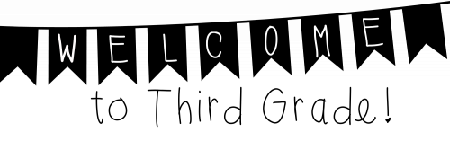

Dear Third Graders and Families,

Welcome to third grade at Barclay Elementary School! My name is Mrs. Landis, and I am very excited to be your 3rd grade teacher this year. I have been teaching at John Barclay for more than twenty years. I graduated with my Elementary Education Degree from West Chester University and later received my Reading Specialist Master’s Degree from Holy Family University.

I look forward to an incredible year in 3rd grade. We will be learning many things in the year to come, including how to work together as a team. We will be exploring many topics, including motion, life cycles, the solar system, multiplication and so much more! I will be building and strengthening those skills that you have learned throughout your primary school years. We will have many fun adventures together throughout the year!

I hope you have an enjoyable summer. On our first day of school, please make sure to bring your school supplies, a healthy snack, and a photo or drawing of your favorite summer activity. I can’t wait to see you in August and hear about all the wonderful things that you did over the summer. I’m looking forward to a wonderful year!
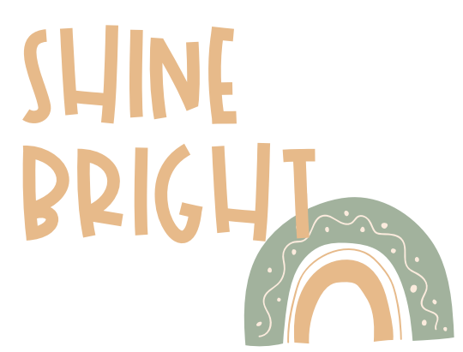
Sincerely,

Mrs. Christine Landis
clandis@cbsd.org

